DATE:06/09/2022
EXPERT:Mr..kartik patel
The webinar on “Sensitization Program” was organized on 06 sep 2022 at Gokul Global university by SSIP Cell. The session was organized for the students of Bachelor of Engineering ALL Branch year with the permission of Dr Bhargav Majumdar Dean. The seminar was organized to provide exposure innovation, what is SSIP, How to Participated all engineering faculty member and 100 students participated in this seminar. Respected provostDR.sunil joshi sir encourage the students about SSIP.Mr.kartik patel is provide knowledge of SSIP and also awareness about various start up
At the end of the session Dr. Himmatsinh RAJPUT ,Registrar gave a vote of thanks .
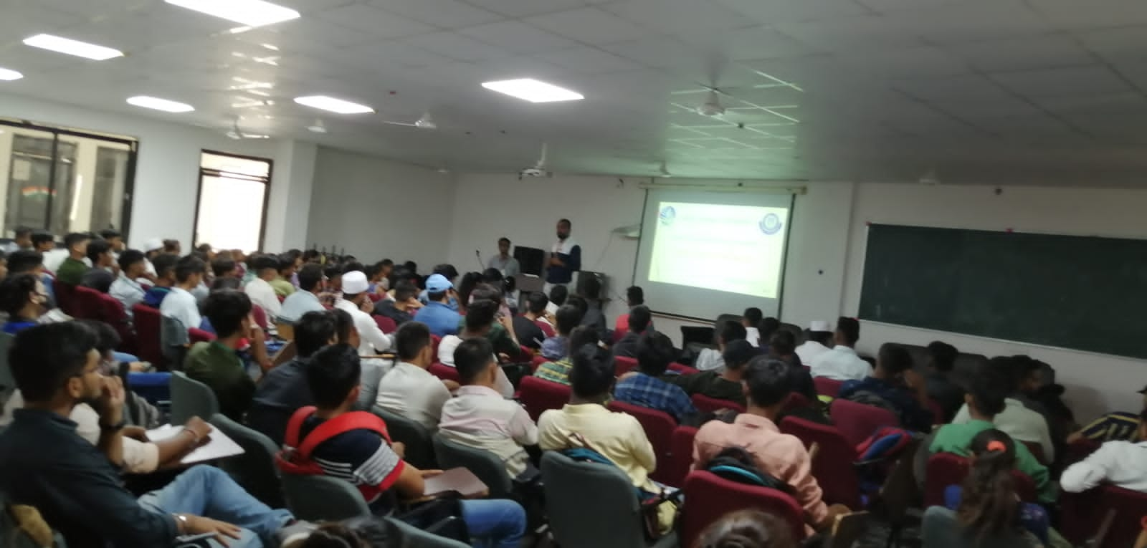 | 